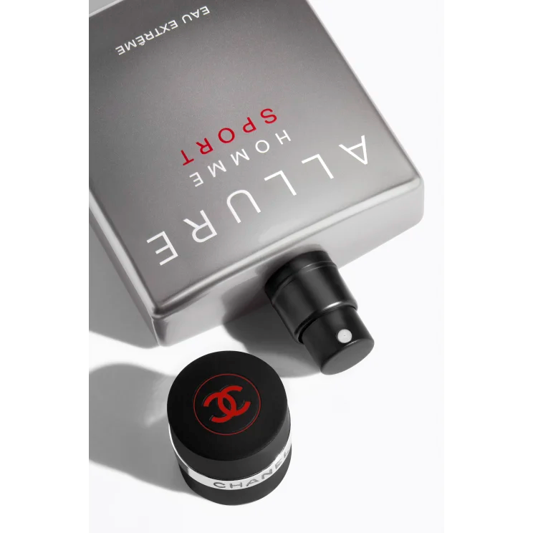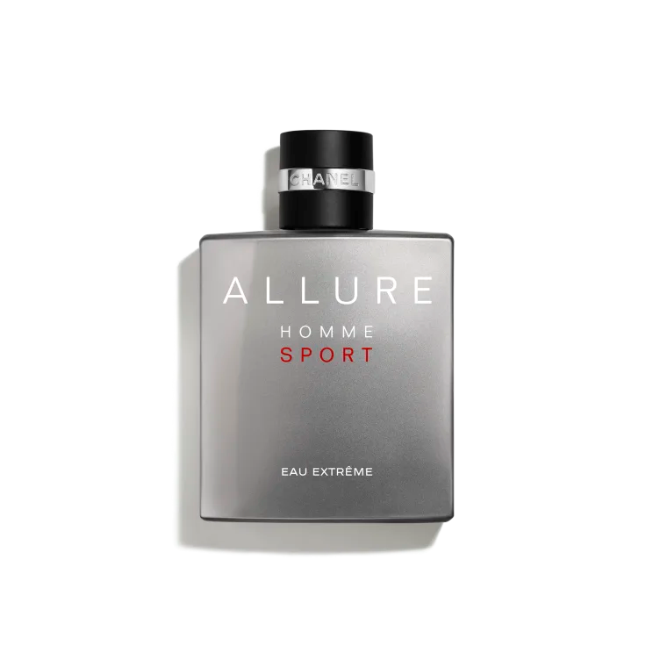

**ALLURE HOMME SPORT**

**$160**

Tax Included.

Spray 100 mL

IN STOCK

**Product Details**

An energizing woody fragrance that strikes a balance between freshness and sensuality. For a singularity personality, someone who loves the great outdoors and lives life with style.